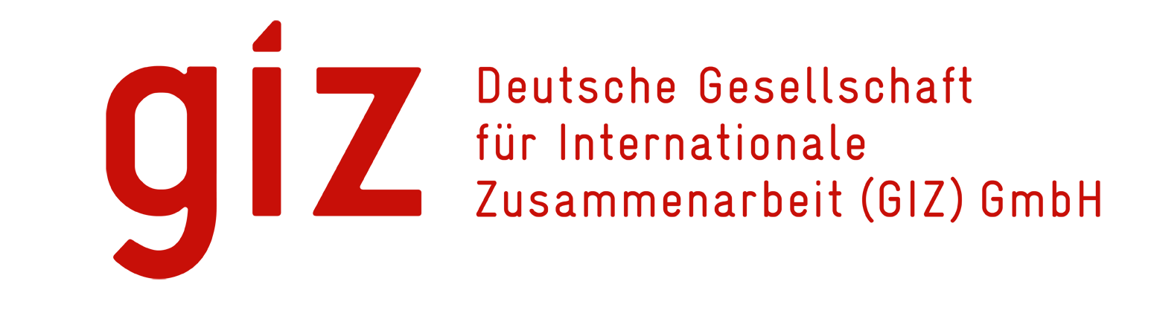
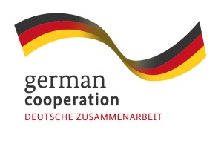

European Union
REGIONAL INCEPTION WORKSHOP
EU – GIZ Adapting to Climate Change and Sustainable Energy (ACSE) Programme
Funded by the European Union EDF10
DRAFT Agenda, 29th – 30th May 2014
Venue tbc, FIJI
Time | Item | Content | Presenter /Facilitator
DAY 1 | 29th May | Introduction to the GIZ-ACSE programme and procedures
8.00 | Registration |  | Secretariat
8.30 | Opening
8.30 |  | Prayer
8.40 |  | Welcome | GIZ
8.45 |  | Opening address | PIFS
8.55 |  | Opening address | EU
9.00 |  | Workshop overview: purpose, objectives and process, what results do we want at end of workshop | GIZ
9.20 |  | Introduction of participants | All
9.40 |  | Logistical updates / group photo | All
9.50 | Morning Tea
10.20 | Session 1 | ACSE and GIZ Component purpose and objectives
10.20 |  | Introduction to whole ACSE | EU
10.30 |  | GIZ-ACSE objectives, overall process for project preparation, eligibility, partners, budget, timeline | GIZ
11.00 |  | Q&A
11.20 |  | Presentation of proposal for Steering Committee | GIZ
11.35 |  | Discussion and agreement on way forward | All
11.55 |  | Presentation of proposal for Assessment Committee | GIZ
12.10 |  | Discussion and agreement on way forward | All
12.30 | Lunch
2.00 | Session 2 | Detailed information on concept notes
2.00 |  | Concept note guidelines, template, criteria and weighting and examples of types of eligible projects | GIZ
2.30 |  | Questions and answers | All
2.45 |  | Indicative example of a filled out concept note | GIZ
3.00 |  | Countries to present on past projects, success factors, lessons learnt, projects with potential to replicate or expand / Filling out the concept template for indicative project ideas | Countries
3.30 | Afternoon tea
4.00 |  | Filling out the template for indicative project ideas cont. | As above
5.00 | Close of day 1

Time | Item | Content | Presenter /Facilitator
DAY 2 | 30th May | Guidelines for developing concept notes and full project proposals
8.00 | Registration |  | Secretariat
8.30 | Session 3 | GIZ-ACSE Programme Planning
8.30 |  | Prayer
8.40 |  | Sub-regional workshops | GIZ
9.00 |  | Q&A
9.20 |  | Introduction to procedures for full proposal preparation and introduction to technical and financial criteria and procedures
9.40 |  | Q&A
10.00 | Morning tea
10.30 | Session 4 | Information session for concept and proposal preparation
10.30 |  | Going through concept note templates (picking up on queries from Day 1 afternoon) | GIZ (Each of these presentations will have time for a Q&A at the end)
10.50 |  | Guidelines on: Logical framework and M&E
11.20 |  | Participatory consultation
11.40 |  | Cost benefit analysis
12.00 |  | Environmental issues
12.20 |  | Gender issues
12.40 | Lunch
2.00 | Session 5 | Preparing concept notes
2.00 |  | Time on preparing concept notes using template | Countries working in groups with roaming facilitators from GIZ
3.15 | Afternoon tea
3.45 | Session 6 | Next steps
3.45 |  | Round-up of workshop activities | GIZ
4.00 |  | Actions, responsible entities and timelines | GIZ
4.20 |  | Discussion and agreement on way forward | All
4.40 | Closure
4.40 |  | Words of thanks | GIZ
4.50 |  | Closing remarks | PIFS

